PQRS Incentives, Penalties and the Coming Value Based Payment Modifier Link to Article
The following is a guest post by Barry Haitoff, CEO of Medical Management Corporation of America.
Much of the focus of healthcare has been on meaningful use and the EHR incentive money. Considering we just reached $19 billion of payouts, it’s definitely a topic worthy of attention. However, a topic which hasn’t gotten nearly as much attention, but is nearly or possibly more important than meaningful use is PQRS and the Value Based Payment Modifier.
Before I dig into some of the details and timelines for PQRS and the Value Based Payment Modifier, it’s really important to note that both of these programs are really just a preview of what’s happening with Medicare reimbursement. These programs are the core of the shift towards paying physicians differentially based on the quality and cost of the care they provide and away from the traditional fee for service model. We’ve seen similar value based payment arrangements with the advent of ACOs, CINs and other clinical networks establishing innovative payment models with payers. Understanding where these programs are going will give you a preview of what’s happening with healthcare reimbursement.
PQRS
When it comes to PQRS, much like meaningful use, there is both a PQRS incentive and PQRS penalty (carrot and stick if you prefer). 2014 is the final year to receive the PQRS incentive money (0.5% of Medicare Part B claims) and participants must submit 12 months of 2013 CQM data by February 28, 2014 if reporting by claims data, March 21, 2014 if reporting by GPRO web interface, and March 31, 2014 if reporting by registry data. (Note: The 2013 MU reporting deadline was moved to March 31, 2014, but the PQRS deadlines have not changed.). However, more important is that providers who don’t report PQRS 2013 data will be penalized 1.5% in 2015. Those who don’t participate in PQRS in 2014 will be penalized 2% in 2016.
Value Based Payment Modifier
While most people have heard about PQRS and are hopefully participating to avoid the penalties, many people haven’t heard about the Value Based Payment Modifier that is built on the PQRS foundation. While you could look at the Value Based Payment Modifier final rule, this Value-Based Payment Modifier summary is a much better overview of the program.
Essentially, the Affordable Care Act (ACA) required that CMS implement a value based payment modifier that would apply to Medicare fee for service payments. This program will start with physicians in groups of 100 or more eligible professionals under the same TIN beginning January 1, 2015, and apply to all physicians and groups by January 1, 2017. CMS also recently announced that this applies to both par and non-par Medicare providers with 100 or more eligible professionals.
Here’s a look at how this new Value Modifier will work for groups of physicians with 100 or more eligible professionals and will likely be a preview of what’s to come for all Medicare physicians:
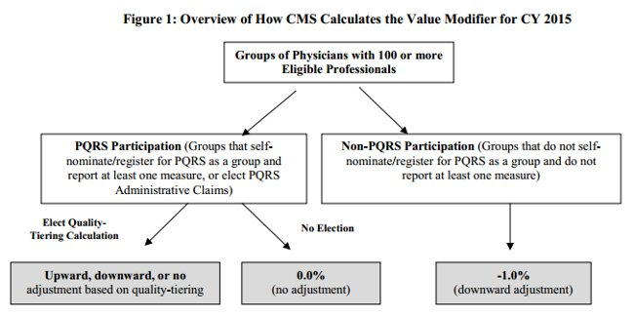
While the program starts with relatively small 1% adjustments, this quote from CMS also provides a clear indication of where they want to take this program:
We also anticipate that we would propose to increase the amount of payment at risk for the Value Modifier as we gain additional experience with the methodologies used to assess the quality of care, and the cost of care, furnished by physicians and groups of physicians.
What should you do to be prepared for this new Value Based Payment Modifier?
1. Participate in the PQRS program since it’s the foundation of what’s to come.
2. Keep an eye on changes to the PQRS and Value Based Modifier programs. They are changing regularly and it’s worth knowing what’s changing with these programs.
3. Work with your professional organization to provide feedback on these programs. No doubt they’re keeping an eye on them and providing feedback as part of the government rule making process. Make sure your voice is heard.
CMS looks at this new value based modifier as a budget neutral program. That means that there are going to be winners and losers. By understanding how these programs work, you can better assess if you want to work to avoid the payment adjustments or if you’re ok taking them on.
Like it or not, PQRS is the start of the movement towards quality based reimbursement and likely a small preview of coming attractions. Of course, if the SGR Fix gets funded by congress, then PQRS, Meaningful Use and the Value Based Modifier will be sunset at the end of 2017 and rolled into a new Merit-Based Incentive Payment System (MIPS) that will start in 2018. More on MIPS in the future, but I think we can safely say that MIPS will be an amalgamation of all these incentive programs.

