05.16.2023 - RELEASE REPORT

PIMSY Plan | PIMSY Department | PIMSY Screen | PIMSY Platform | Type | Release Notes
Professional  Platinum | Medical Records | Messaging | Desktop | Fix | We have fixed an issue where email reminders to clients were not being formatted correctly and were missing the portal link.
Professional  Platinum | Billing / Invoicing | Invoices | Desktop | Enhancement | New Split Invoice Rules/Permissions  We have added new profile rules to restrict the splitting of invoices by users that have not been given permission to do so. Copying a split invoice will also be restricted. These new rules include:  - Split Invoice Reverse / Undo  - Split Invoice Modify  - Split Invoice Create
Platinum | Calendar / Scheduler | Scheduler | Desktop | Enhancement | Specialty User Tags  A new tab has been added in the scheduler area simply for filtering based on a user tag called Specialties. This enhancement provides a new way to filter in the Scheduler for users based on their specialty, location, and/or user group. To see a guide on this new enhancement, click here.
Professional  Platinum | Medical Records | Forms | Client Portal | Enhancement | Q&A Display Order  We have added a display order to the Q&A exposed on the Client portal. The display order can be located in the Q&A setup.

See the next page for more details

Desktop
Specialty User Tags for Scheduler
- We have added a new tab in the Scheduler simply for filtering based on a new user tag called Specialties. This enhancement provides a new way to filter in the Scheduler for users based on their specialty, location, and/or user group.
- User Specialties is now an option under Tag Category in Picklist Management and can be attached to users in the system.
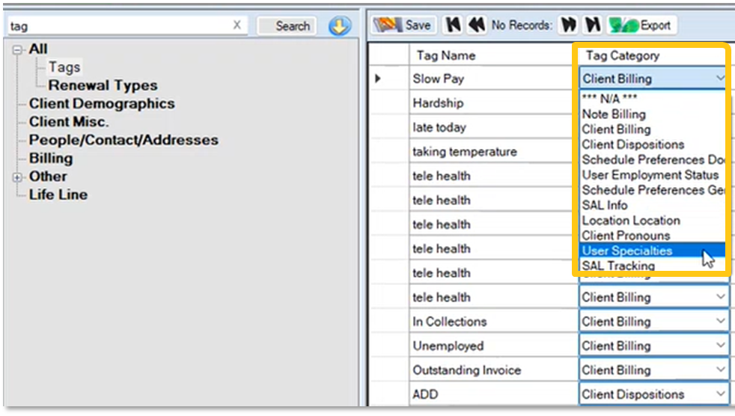
- User specialty tags can be added, edited, or removed in the User Personnel folder under User Management.
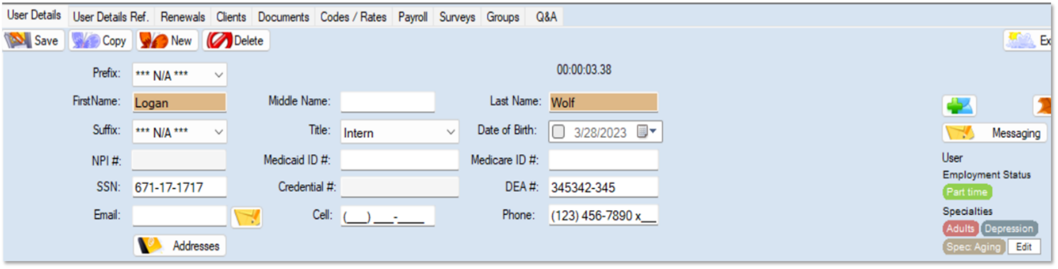
- User Specialties can be searched for by going to the Specialties tab on the scheduler. Here users can select tags to search for and view the user list according to the selected criteria.
